1. **Getting Started:**

* **Watch this short video to understand how the system works behind the scenes:**

[**https://youtu.be/7KU_jGE58Cc**](https://youtu.be/7KU_jGE58Cc)

**-Watch this tutorial to get started**

[**https://youtu.be/g1fz0Iq5PT4**](https://youtu.be/g1fz0Iq5PT4)

1. **Steps:**

* **In your script Create a ComboSequencer Object**
* **Call the Initialise() method in Start()**
* **Call the Update() method in your Update Loop**
* 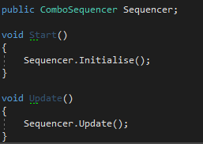**Assign combos and the Animator references in the inspector**
* **Hit play!**

**Credits:**

* **Animations included: Mixamo’s Melee Axe**

[**https://assetstore.unity.com/packages/3d/animations/melee-axe-pack-35320**](https://assetstore.unity.com/packages/3d/animations/melee-axe-pack-35320)

* **Axe Model: Horror Axe by** ESsplashkid

**https://assetstore.unity.com/packages/3d/props/tools/horror-axe-107507**